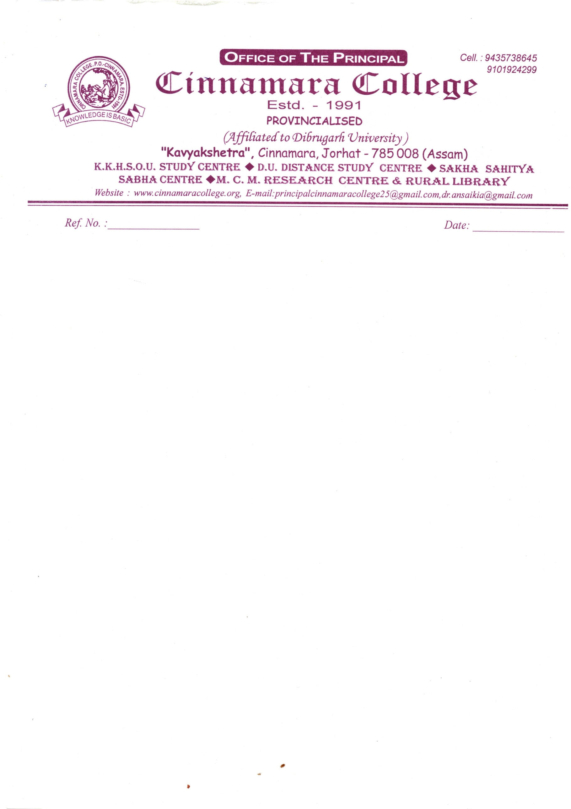

**20/12/2021**

**NOTICE**

It is hereby inform to all 1st/3rd/5th Semester (NON-CBCS) Students that the Formfillup will be starts from 21th December to 23rd December,2021.

Sd/-

Dr.Anjan Saikia

Principal

Cinnamara College

Cinnamara,Jorhat-8