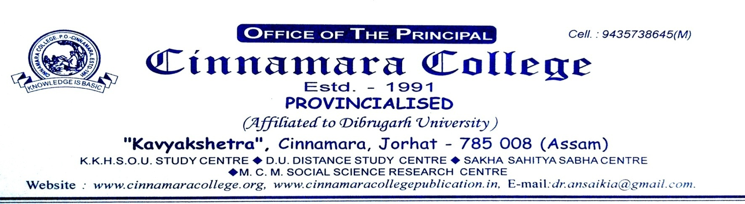

***9101924299 (M& W)***

Date: 21-08-2021

**NOTIFICATION FOR THE ADMISSION FOR 2ND LIST**

The admission portal of 2nd list B.A. Ist Semester CBCS Course is opened and will continue up to 26th August, 2021.



(Dr. Anjan Saikia)

**Principal**

Cinnamara College

Cinnamara, Jorhat-8