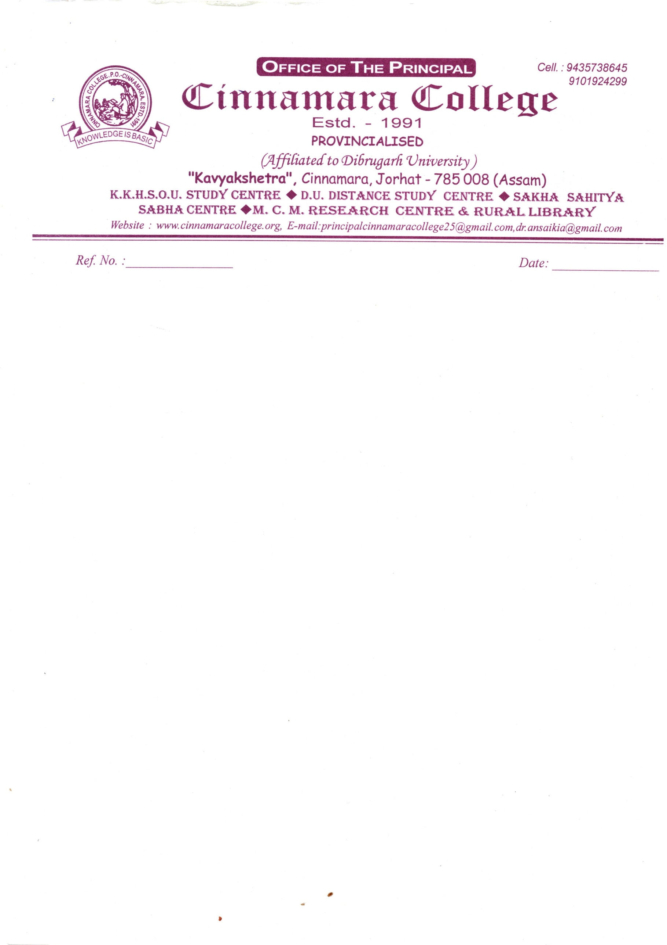

30/07/2022

**NOTICE**

It is hereby inform to all newly admitted B.A 1st Semester (CBCS) students that the College classes will be started from 16/08/2022.

Principal

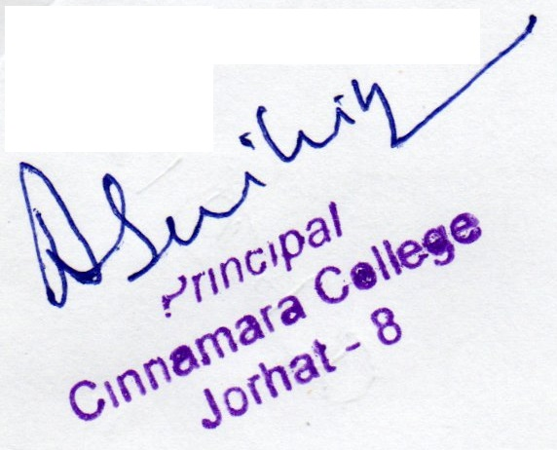

Cinnamara College

Cinnamara , Jorhat-8